**Gait Kinematics in Two Female Participants with and without Ankle Instability**

**Shiyuan Li1, Shervindokht Shams 1, Yifei Wang 1, Minoo Haghnevis 1, Faisal Mohammed 1, Rabia Shahid 1**

Institute of Biomechanics and Orthopedics, German Sport University Cologne, Cologne, Germany 1

Chronic ankle instability (CAI) is a common issue in physically active individuals, often leading to long-term changes in movement and joint control. This study aimed to compare the gait patterns of two female participants—one healthy and one diagnosed with CAI—using a simple 2D video analysis method. The results showed that the participant with CAI exhibited reduced ankle and knee joint mobility, as well as more irregular hip joint displacement, velocity, and acceleration compared to the healthy control. These differences suggest altered movement strategies likely developed to compensate for joint instability. Despite the minimal setup, the study was able to clearly identify key differences in gait between the two subjects, and highlights the potential of more accessible tools to support early diagnosis and help guide rehabilitation strategies in clinical or sports settings.

**KEYWORDS**: Chronic Ankle Instability, Gait, 2D Motion Analysis, Lower Limb Kinematics

**INTRODUCTION:** Chronic lateral ankle sprain is a very common injury in people involved in physical activities and sports, which persists even after the complete recovery of injury(Fong et al., 2007). Chronic ankle Instability (CAI) is the subjective dysfunction and instability that occurs initially twelve months after first lateral ankle sprain (LAS) and is linked to self-reported “giving away”(Yeung et al., 1994). In addition to the tendency of recurrent LAS after 1 year of index LAS, CAI is characterized by ongoing symptoms such as pain, weakness, edema, restricted mobility, and impaired self-reported functionality(Hertel & Corbett, 2019).Alterations in the lower extremities, such as kinetics and kinematics, and sensorimotor dysfunction have been found to be associated with chronic ankle instability(Chinn et al., 2013). Subjects with CAI have been shown to have kinematic abnormalities in frontal and sagittal plane ankle movements during locomotion(Drewes et al., 2009).Patients with this condition demonstrated a greater inverted ankle position and plantar flexion(Milgrom et al., 1991). It has been hypothesized that this posture enhances the possibility of further injury(Herb et al., 2014).

Clinical gait analysis has been used for many years to provide objective valuable information on neuromuscular and mechanical deficits in subjects with chronic ankle instability(Hertel & Corbett, 2019).Individuals with CAI were reported to have larger ankle inversion angles during walking, which exerts additional strain on the lateral surface of the foot and make the ankle more prone to recurrent sprain(Koldenhoven et al., 2016).Only very few studies compared the biomechanics of lower extremity in healthy controls and individuals with CAI. The main objective of this study was to compare the gait kinematics between a female subject with chronic ankle instability and a healthy control using 2D video analysis. This study hypothesized that individuals with CAI will have restricted range of motions of both knee and ankle joints.

**METHODS:** Two female subjects (26.5±0.5 years old) were recruited randomly, representing healthy control and those diagnosed with ankle instability within six months prior to the study (case subject), respectively. Both reported performing moderate-intensity physical exercise 3 times a week. The case subject has chronic ankle sprain (CAS) history and was diagnosed with ankle instability. Informed consents were taken from participants before data collection.

A 2D video analysis setup was built to evaluate gait characteristics. A Baumer VCXU-23C camera was used to capture the movement(Muro-de-la-Herran et al., 2014). The camera settings included a frame rate of 50 fps, shutter speed of 1/170 s, and gain set to 130(Payton & Bartlett, 2007; Richards, 1999). It was positioned from a side view (sagittal plane) to properly capture the left leg during walking. Each participant walked along a straight path at their normal walking speed. For each subject, three gait trials were recorded.

Reflective markers were attached to four main anatomical points on the left lower limb: Greater trochanter (representing hip joint and approximating CoM), Lateral femoral condyle, Lateral malleolus, and Lateral metatarsophalangeal joint(Cappozzo et al., 1995).

The videos were first processed in Kinovea to track marker positions frame by frame. The 2D coordinates and linear (hip joint displacement, velocity and acceleration) and angular (knee and ankle joint angles) kinematic variables were extracted with Kinovea, which were then exported and visualized using Python. 5 strides of healthy subject and 6 strides of case subject were finally extracted and analyzed upon inspection, where the average results together with error range of 1 standard deviation normalized by gait cycle were demonstrated.

**RESULTS:** The healthy control (hereinafter A1) demonstrated greater horizontal displacement with a wider and more consistent velocity range, reflecting a dynamic and efficient gait cycle, while the case subject (hereinafter A2) exhibited lower horizontal displacement and velocity with an asymmetrical vertical pattern between steps (Figure 1), likely due to the compromised ankle stability and compensatory strategies. A1’s vertical hip joint motion was smooth and maintained consistent amplitude across steps, while A2 displayed more fluctuation in the vertical velocity, indicating challenges in the vertical stability during gait phases (Figure 2).

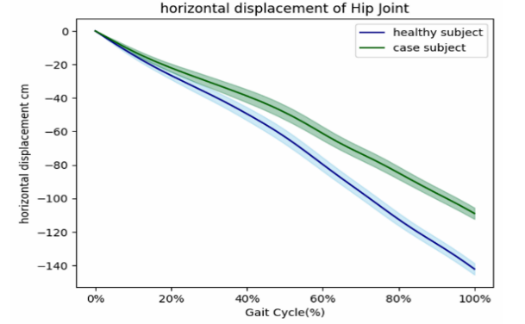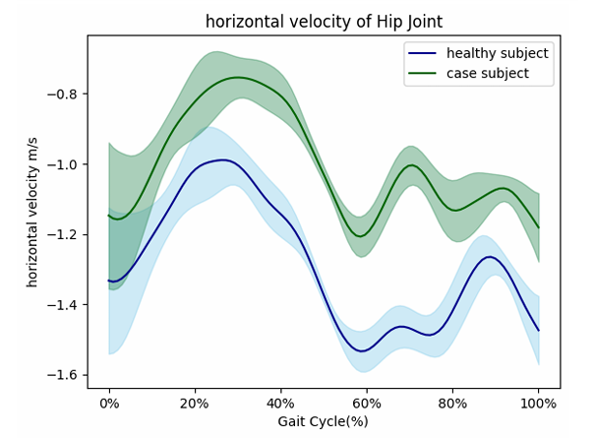

**Figure 1: Horizontal Displacement (Left) and Velocity (Right) of Hip Joint**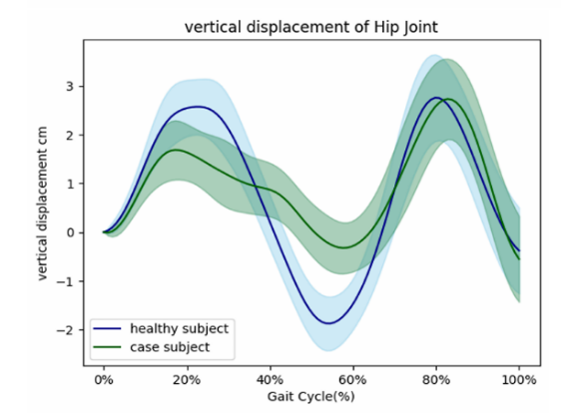 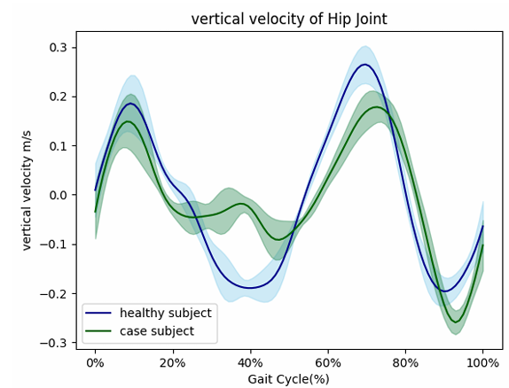

**Figure 2: Vertical Displacement (Left) and Velocity (Right) of Hip Joint**

For the acceleration of hip joint, A1 showed higher magnitude and range and consistent patterns, especially in the vertical direction, suggesting higher magnitude, range, and consistent pattern of force generation. Similar to other variables, A2’s acceleration curves were more irregular and unpredictable, indicating difficulty in generating and controlling vertical motion forces.

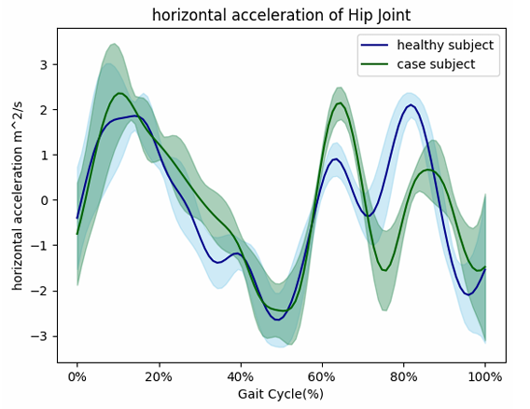 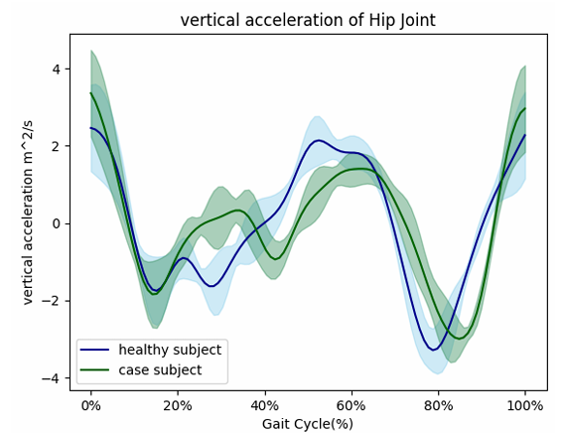

**Figure 3: Horizontal (Left) and Vertical (Right) Acceleration of Hip Joint**

A1 exhibited a large range of motion at ankle joint ranging from 105° to 145° indicative of healthy dorsiflexion and plantarflexion, and A2 demonstrated a reduced ankle angle from 100° to 135°, indicating restricted mobility, a characteristic hallmark for CAI. A1’s knee angle profile exhibited dynamic fluctuation, typical for a normal and healthy gait pattern, while A2’s knee motion was less undulating, the visual range of A2’s knee angle curve doesn’t clearly appear narrower. However, the overall stiffness in A2’s pattern may still reflect a more controlled movement influenced by reduced ankle function.

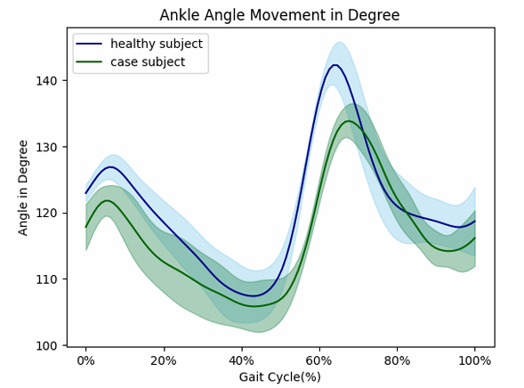 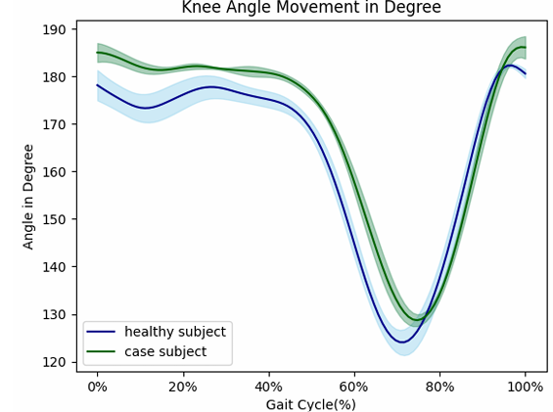

**Figure 4: Ankle Angle (Left) and Knee Angle (Right)**

These results support the hypothesis that subjects with CAI (A2) demonstrate a restricted joint motion, particularly at ankle joint, and exhibit more inconsistent gait kinematics as compared to the healthy controls (A1).

**DISCUSSION:** The results showed that the participant with CAI (A2) had restricted movement in ankle and knee joints and more irregular movement of hip joint during walking. These findings are similar to previous studies that found people with CAI often move differently, especially showing more ankle inversion and less joint flexibility when walking(Delahunt et al., 2006).

The changes we saw in A2’s walking could be the body’s way of protecting the unstable ankle. It can be speculated that she was walking more carefully, likely to avoid pain or further injury. Other research also shows that people with CAI often use these kinds of movement strategies(Brown & Mynark, 2007). We also noticed that her hip joint didn’t move as smoothly as the healthy participant’s, which suggests she had more trouble keeping balance while walking. This supports earlier research showing that how the CoM moves is closely related to how stable and efficient someone walks(Winter, 1995). Even though we only used a basic camera setup and free software like Kinovea, we were still able to see clear differences in gait. This shows that 2D video analysis can be a useful tool for clinics or small labs that don’t have access to expensive 3D motion systems (Puig-Diví et al., 2019). Of course, using more advanced equipment like force plates or EMG would give even more detailed information, especially about muscle activity and the forces at play. As Ferber et al. (2016) pointed out, combining several tools gives a deeper understanding, but even simple methods like ours are still useful in many cases.

This study had some limits. First, we only looked at two people, so the conclusions can’t be generalized to a larger population. Also, we only recorded from one side, so we missed some important movements from other perspectives. We didn’t include tools like EMG or pressure sensors, which could have given us more insight into how the body works during walking. For future research, it would be great to study more people and use more advanced tools. Also, testing people in different walking conditions—like on uneven surfaces or after getting fatigued—might show us more realistic movement problems that people with CAI face in everyday life.

**CONCLUSION:** This study showed that subjects with CAI exhibited reduced ankle and knee joint mobility, as well as more irregular hip joint linear kinematics compared to healthy subjects. Our findings support what other researchers have found—that CAI affects how people walk. The study also exemplifies how simple tools can be applied to spot movement problems, which could be helpful for early diagnosis and planning better treatments.

**REFERENCES**

Brown, C. N., & Mynark, R. (2007). Balance deficits in recreational athletes with chronic ankle instability. *J Athl Train*, *42*(3), 367-373.

Cappozzo, A., Catani, F., Croce, U. D., & Leardini, A. (1995). Position and orientation in space of bones during movement: anatomical frame definition and determination. *Clin Biomech (Bristol)*, *10*(4), 171-178. <https://doi.org/10.1016/0268-0033(95)91394-t>

Chinn, L., Dicharry, J., & Hertel, J. (2013). Ankle kinematics of individuals with chronic ankle instability while walking and jogging on a treadmill in shoes. *Phys Ther Sport*, *14*(4), 232-239. <https://doi.org/10.1016/j.ptsp.2012.10.001>

Delahunt, E., Monaghan, K., & Caulfield, B. (2006). Altered neuromuscular control and ankle joint kinematics during walking in subjects with functional instability of the ankle joint. *Am J Sports Med*, *34*(12), 1970-1976. <https://doi.org/10.1177/0363546506290989>

Drewes, L. K., McKeon, P. O., Paolini, G., Riley, P., Kerrigan, D. C., Ingersoll, C. D., & Hertel, J. (2009). Altered ankle kinematics and shank-rear-foot coupling in those with chronic ankle instability. *J Sport Rehabil*, *18*(3), 375-388. <https://doi.org/10.1123/jsr.18.3.375>

Ferber, R., Osis, S. T., Hicks, J. L., & Delp, S. L. (2016). Gait biomechanics in the era of data science. *Journal of biomechanics*, *49*(16), 3759-3761. <https://doi.org/10.1016/j.jbiomech.2016.10.033>

Fong, D. T., Hong, Y., Chan, L. K., Yung, P. S., & Chan, K. M. (2007). A systematic review on ankle injury and ankle sprain in sports. *Sports Med*, *37*(1), 73-94. <https://doi.org/10.2165/00007256-200737010-00006>

Herb, C. C., Chinn, L., Dicharry, J., McKeon, P. O., Hart, J. M., & Hertel, J. (2014). Shank-rearfoot joint coupling with chronic ankle instability. *J Appl Biomech*, *30*(3), 366-372. <https://doi.org/10.1123/jab.2013-0085>

Hertel, J., & Corbett, R. O. (2019). An Updated Model of Chronic Ankle Instability. *J Athl Train*, *54*(6), 572-588. <https://doi.org/10.4085/1062-6050-344-18>

Koldenhoven, R. M., Feger, M. A., Fraser, J. J., Saliba, S., & Hertel, J. (2016). Surface electromyography and plantar pressure during walking in young adults with chronic ankle instability. *Knee Surg Sports Traumatol Arthrosc*, *24*(4), 1060-1070. <https://doi.org/10.1007/s00167-016-4015-3>

Milgrom, C., Shlamkovitch, N., Finestone, A., Eldad, A., Laor, A., Danon, Y. L., Lavie, O., Wosk, J., & Simkin, A. (1991). Risk factors for lateral ankle sprain: a prospective study among military recruits. *Foot Ankle*, *12*(1), 26-30. <https://doi.org/10.1177/107110079101200105>

Muro-de-la-Herran, A., Garcia-Zapirain, B., & Mendez-Zorrilla, A. (2014). Gait analysis methods: an overview of wearable and non-wearable systems, highlighting clinical applications. *Sensors (Basel)*, *14*(2), 3362-3394. <https://doi.org/10.3390/s140203362>

Payton, C. J., & Bartlett, R. (2007). *Biomechanical evaluation of movement in sport and exercise*. Routledge Abingdon, Oxon, UK.

Puig-Diví, A., Escalona-Marfil, C., Padullés, J., Busquets Faciaben, A., Padullés, X., & Marcos-Ruiz, D. (2019). Validity and reliability of the Kinovea program in obtaining angles and distances using coordinates in 4 perspectives. *PLoS One*, *14*, e0216448. <https://doi.org/10.1371/journal.pone.0216448>

Richards, J. G. (1999). The measurement of human motion: A comparison of commercially available systems. *Human Movement Science*, *18*(5), 589-602. <https://doi.org/https://doi.org/10.1016/S0167-9457(99)00023-8>

Winter, D. A. (1995). Human balance and posture control during standing and walking. *Gait & Posture*, *3*(4), 193-214. <https://doi.org/https://doi.org/10.1016/0966-6362(96)82849-9>

Yeung, M. S., Chan, K. M., So, C. H., & Yuan, W. Y. (1994). An epidemiological survey on ankle sprain. *Br J Sports Med*, *28*(2), 112-116. <https://doi.org/10.1136/bjsm.28.2.112>